**Recon AI Documentation**

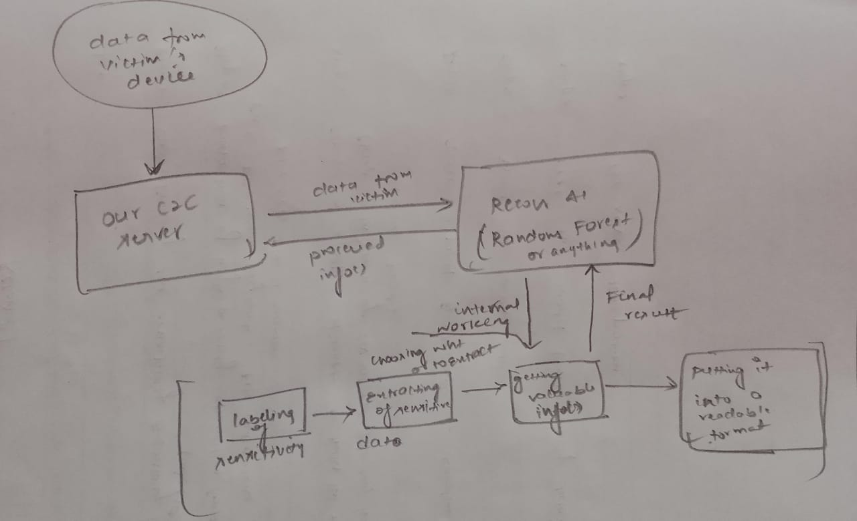

Fig. Recon Architecture

**Basic goal :**

* To develop a model that works on the info() gathered by the Malware.
* It should be Intelligent enough to **classify** the collected info into three classes : High , Low and None
* And them **extract possible sensitive info()** and share it as the output back to C2C

**Model Selected** : RANDOM FOREST